**IOT BASED BLOOD PRESSURE MONITORING SYSTEM**

**S. SHALOMSHAN**

**AIT190806**

**PEARSON REGISTRATION NO: -**

This Dissertation is submitted to the Department of Computing, School of Computing, British College of Applied Studies in partial fulfilment of the Requirements of the BTEC Higher National Diploma in Computing.

**Department of Computing**

**School of Computing**

**British College of Applied Studies**

**2021**

# DECLARATION

I do hereby declare that this work has been originally carried out by me under the guidance of Mr. A.R. Mohamed Nizzad, Senior Lecturer, Department of Computing, and this work has not been submitted elsewhere for any other diploma or degree.

I certify that this dissertation does not incorporate without due acknowledgement of any material previously submitted for diploma or degree in any institution or university nor it does not contain any material previously published or unpublished by another person except where due reference is made in the text.

……………………….

Signature of Candidate

SHALOMSHAN

PEARSON NO:-

# CERTIFICATION

This is to certify that the dissertation titled “**IoT Based Blood Pressure Monitoring System”** is submitted by **S. SHALOMSHAN** having the PEARSON Registration No ABC013 to the Department of Computing School of Computing, British College of Applied Studies in partial fulfillment of the requirements for the award of the BTEC Higher National Diploma in Computing.

I also certify that this is his original work based on the studies carried out independently by him during the period of study under my guidance and supervision.

This is also to certify that the above dissertation has not been previously formed the basis for the award of any degree, diploma, fellowship or any other similar title.

……………………………

(Signature of Supervisor)

A.R. Mohamed Nizzad

Senior Lecture

Department of Computing

School of Computing

British College of Applied Studies

………………………………..

Date

# ACKNOWLEDGEMENT

With immense gratitude and accomplishment, I write this note of acknowledgement where I must thank my module lecturer Mr. K.M Ishraque and my supervisor Mr. A.R Mohamed Nizzad who supported and guided me to achieve this milestone.

I also take this moment to thank my parents, family and friends who supported me in one or the other to complete my research work in a successful manner.

# ABSTRACT

Blood pressure is an indicator of various diseases in the body such as high blood pressure, coronary heart disease, and kidney disease. Not only that but the number of patients in the hospital is increasing every year and the blood pressure of some patients has to be measured regularly by the medical staff. This is why the public needs the help of knowledgeable companies related to measuring blood pressure. To this end, the IoT Based Blood Pressure Monitoring System is designed to remotely monitor a patient's blood pressure.

This program uses the Arduino as a gateway to view the value of blood pressure online. NodeMCU is also used to connect the Arduino to the Internet.

The results showed that it was capable of transferring data from blood pressure detection over the network using a blood pressure device directly connected to the Arduino.

And the user can view the blood pressure reading continuously from the email service as well. Also, this system can accurately measure the value of blood pressure while the user is sitting.

**Keywords: -** Blood Pressure, Internet of Things, Arduino, NodeMCU, Gmail

# CHAPTER ONE

## Introduction

Blood pressure is a measurement of the force applied on the walls of artery vessels as heart pumps blood through the body. Moreover, blood pressure measurement is known as one of the vital signs and is widely used to monitor the physiological condition of human beings along with other vital signs heard rate, breathing rate, oxygen saturation and temperature. Blood pressure can be seen as two variation systolic Blood pressure and diastolic Blood pressure, and systolic is the peak or the maximum pressure on the walls of the arteries which happens when the ventricles of the heart are contacting. While, diastolic is the minimal pressure in the arteries, which happens near that end of cardia cycle when the ventricles are filled with blood. Typically, measured values for a healthy, resting adult are 115 millimeters of mercury (mmHg) (15 kilopascals{kPa}) systolic and 75 mmHg (10 kPa) diastolic. Systolic and diastolic blood pressure measurements are not always static and Blood pressure dose tend to change during the day. They also change in response to stress nutrition, drugs, and illness and exercise.

The measurement of Blood Pressure is of a great importance because it is used for detection of hypertension (High Blood Pressure). Hypertension is continuous, consistent, and independent risk factor for developing cardiovascular disease. Hypertension can cause the blood supply to the brain, heart and other tissues to be too low, and hypertension is strongly correlate with higher risk for cerebral stroke and heart infarct. Blood Pressure measurement is also important for particular disease patients, such as hemodialysis patients. Hence, in the daily life, blood pressure measurement and management are very useful for handling health situation and plays a preventive function.

Annual health statistics in its most recent report noted that the number of patients is increasing. Accordingly, the ministry of health must take on the serious responsibility of providing the best possible health care to all Sri Lankans. Thus, there is a need to simplify the monitoring process inside the hospital in Sri Lanka. It is easier to have online monitoring system to show every condition in engineering. One method is to used Internet of Things (IoT) to monitor the patient’s health. Nowadays there are lot of applications being of hospital’s management. IoT blood pressure monitor designed and develop to help the hospital’s staff monitoring the blood pressure reading of the patient remotely. This will reduce the dependability of the patients towards the hospital’s staff as well as enhancing how doctors make their decision based on the patient condition at the real time. IoT blood pressure monitor is also valuable for elderly or disability patients who might have difficulty to go the hospital to check on their condition. The system is able to expand the medical services setting from patients home due to the doctor’s facility.

### Overview

### Background of Research

Blood pressure is a measure of the force exerted on the walls of arteries as the heart pumps blood through the body. Many researchers have offered to provide a simple solution to monitor this blood pressure. Prior to that, researchers tried to monitor blood pressure by setting up a network based on wireless technologies. In trying to do so they began to use the Internet of Things, a network-based technology of the Tat period. This made it easier for Bluetooth and Wi-Fi technology to access the results of the patient at a distance from the skin on mobile devices such as mobiles, tapes and display the results to the relevant medical authorities. It is noteworthy that a variety of equipment was required to develop this research project, such as the Arduino microcontroller or raspberry pi and the NodeMCU Wi-Fi module and lcd display and blood pressure sensor. How this research program is implemented is that the sensor or blood pressure monitor for measuring blood pressure is connected to all Arduino microcontrollers or raspberry pi so that the sensor or blood pressure monitor is accurately measured and displayed on the Arduino microcontroller or raspberry pi while displaying it on its lcd display The NodeMCU Wi-Fi module is integrated with the Arduino microcontroller as it requires internet access to display the measurement to the relevant medical officer.

Based on the existing research plans, this research is carried out in conjunction with the Arduino microcontroller Arduino to display the measurements available on the blood pressure monitor on the lcd display and then send an email to the relevant medical officer. The Wi-Fi module is connected to the Arduino.

### Problem Statement

This research project is going to be used to measure blood pressure and send it to a medical officer using the Internet of Things (IoT) to email that blood measurement. This means that a digital blood pressure monitor is going to be used to measure the blood pressure. We are going to connect the blood pressure monitor to the microcontroller called Arduino and the lcd display to the Arduino Display. At the same time as displaying the lcd display measurement the NodeMCU will be connected to the Arduino and the receiver from the blood pressure monitor will be emailed to the concerned medical officer.

This research program will benefit many people and will be helpful during emergencies. Taking Sri Lanka in general, many patients nowadays suffer from various ailments and are admitted to medical clinics. It is important for every patient admitted to have their blood pressure measured during an emergency because the need for blood pressure is often high in the hospital as blood pressure is found to be related in some way to the disease itself. That is why it is so necessary to eliminate the alternative to this with a modern technology.

This is why destroying the solution using the internet of things, one of the emerging technologies today, is a great thing. If we look at why there is no need for a patient to go to the same hospital by measuring blood pressure using the internet of things then this internet of things used blood pressure system is that a patient has to go to the hospital everyday if they want to measure blood pressure daily this system is needed when it is used How big is the space if a patient is measuring blood pressure through the blood pressure system used by the internet It is automatic This measurement will go automatically via email to the patient who can see the patient This blood pressure measurement can be viewed by a doctor on his mobile phone, tablets, laptop, desktop The doctor who visits this blood pressure measurement can call his patient and give him a description of the patient's blood pressure measurement.

Using this internet of things-based blood pressure system can reduce wastage of time.

### 1.4 Research Question

What do you want to find out this research?

## 2. Literature Review

## 2.1 Blood Pressure

Blood pressure is the pressure of blood pumped by the heart against the artery walls. In humans, blood is pumped through two separate circulatory systems in the heart namely pulmonary circulation and systemic circulation. Blood pressure is measured by getting systole and diastole, both of which represent the heart when beating and resetting. Systole is a sign when the heart beats and is measured by detecting the first beat when measuring blood pressure while diastole is a sign when the heart is stationary and is measured by detecting the last beat when measuring blood pressure.

TABLE BLOOD PRESSURE RANGE

|  |  |  |
| --- | --- | --- |
| **Status** | **Systole** | **Diastole** |
| Hypotension | <80 | <50 |
| Normal | 80< x <115 | 50< x <60 |
| Elevated | 115< x <124 | 60< x <75 |
| Hypertension | >125 | >75 |

Table 1Blood Pressure Range

## 2.2 Blood Pressure Device

Digital blood pressure monitors are often used on the wrist, but they can also be placed on the finger or upper arm and are activated simply by pressing a button. They read the blood pressure automatically based on variation in the volume of blood in the arteries. When taking blood pressure measurements on the wrist, it’s important to keep the hand level with the heart. Otherwise, it can affect the readings.

Figure Blood Pressure Device

## 2.3 Microcontroller

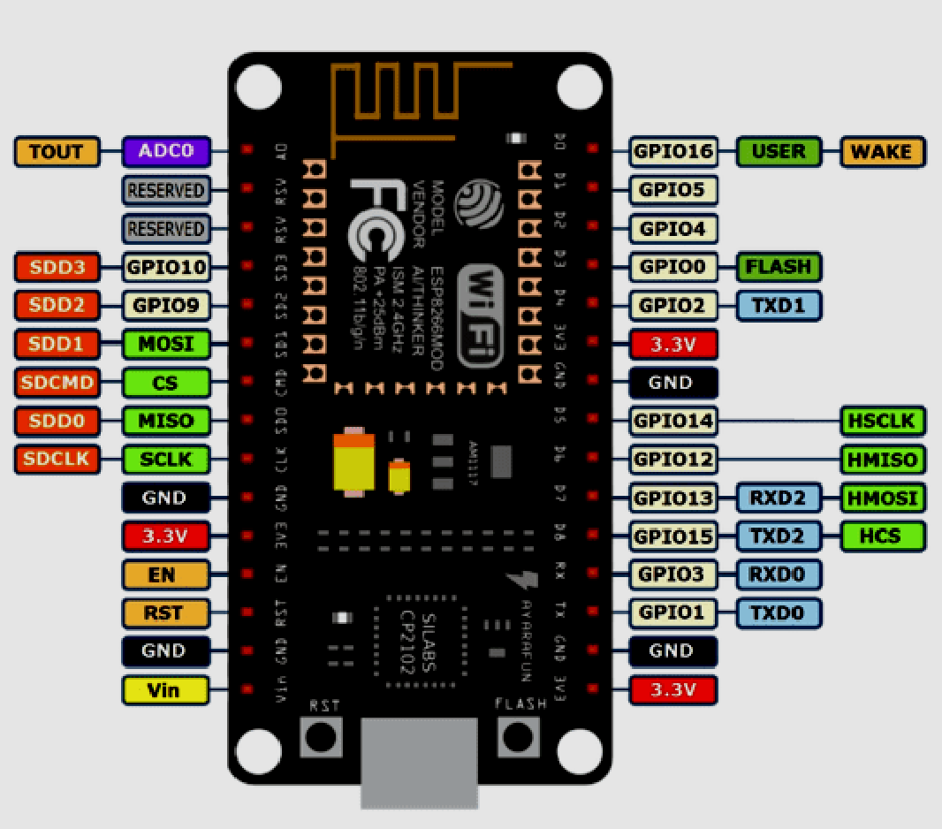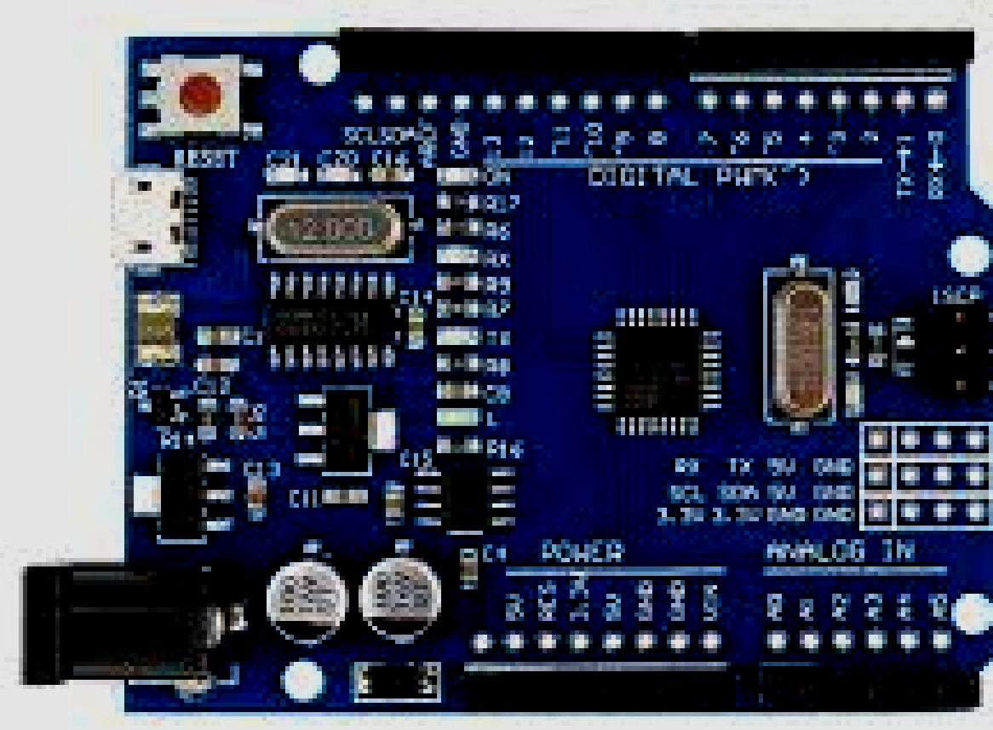The microcontroller is a small computer that contains a microprocessor that can perform arithmetic and logic function. Inside the microcontroller, there is also a memory to store data to be processed. Arduino is one of the microcontrollers that are easy to use in development in this paper Arduino is used as a processer for the value of the readings by Blood Pressure Device and NodeMCU will be as a network interface to connect to Wi-Fi or hotspots.

Figure 2 NodeMCU

*Figure 1 Arduino uno*

*Figure 2 NodeMCU*

## 2.3 Wi-Fi (ESP8266)

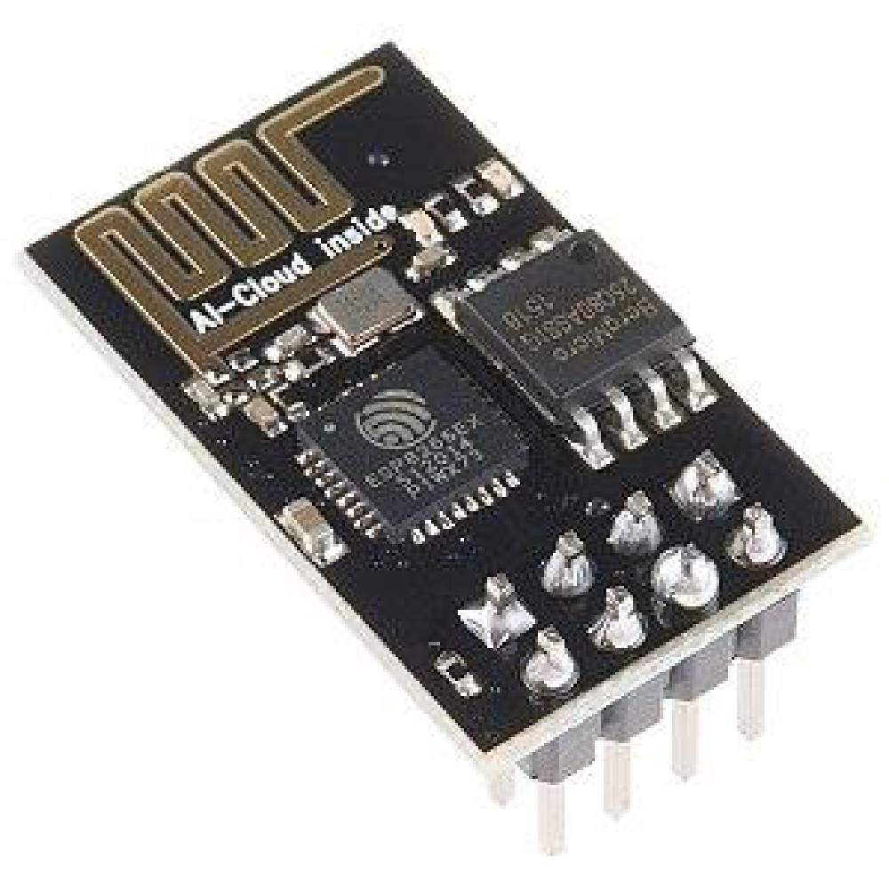

Figure 3 ESP8266

ESP8266 is highly integrated chip designed for the needs of a new connected world.it offers a complete and self-contained Wi-Fi networking solution, allowing it to either host the application or to offload all Wi-Fi networking function from another application processor.

## 2.4 Internet of Things

IoT is a communication network of goods that has Blood Pressure Device and is connected via the internet. In use IoT can adjust human needs based on the Blood Pressure Device used, in this paper we will try to connect the Blood Pressure Device with IoT.

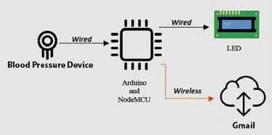

*Figure 4 Block Diagram*

The picture above shows a block diagram of the process of measuring blood pressure until the measurement result are sent to Gmail.

## 2.5 LCD

Figure 5 LCD

*Figure 5 LCD*

A liquid crystal display (LCD) is a flat panel display or other electronically modulate optical device that uses the light modulating properties of liquid crystals. Liquid crystals do not emit light directly instead using a backlight or reflector to produce images in color or monochrome.

## 3. METHODOLOGY

This research employs deductive approach to select the most efficient algorithm by comparing the existing theories, algorithms and tools & technologies available. This research requires the use of both mix method where qualitative and quantitative aspects are incorporated to reach the expected outcome. The psychological aspects are treated and analyzed by means of qualitative approach whereas Internet of Things involves quantitative approach such as statistical computation.

## 3.1 Conceptual Model

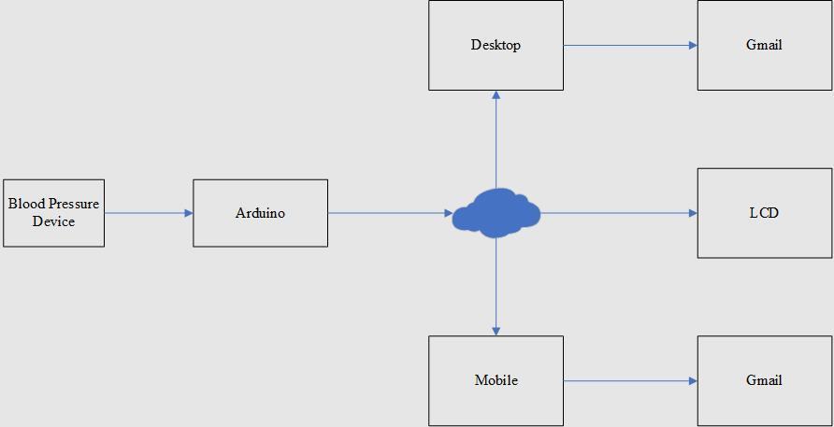

*Figure 6 Conceptual Model*

This project consists of software and hardware implementation. The block diagram of the system designed is explained in Figure 6. The overall system is controlled by Arduino that able to detect data from the blood pressure device and send them over the internet for user view it from Gmail application.

## 3.2 Conceptual Flowchart

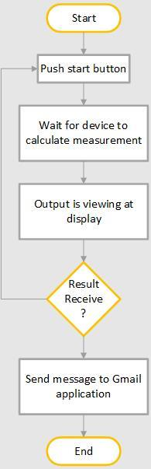

*Figure 7 Conceptual Flowchart*

Figure 7 Conceptual Flowchart

The conceptual flowchart is shown Figure 7. The system starts when a user switch on the blood pressure device. The user then has to wait for the device to obtain the blood pressure measurement. Finally, the output will be displayed at application before transferred to email application.